What is HTML?

* HTML stands for Hyper Text Markup Language
* HTML is the standard markup language for creating Web pages
* HTML describes the structure of a Web page
* HTML consists of a series of elements
* HTML elements tell the browser how to display the content
* HTML elements label pieces of content such as "this is a heading", "this is a paragraph", "this is a link", etc.

### **Example**

<!DOCTYPE html>  
<html>  
<head>  
<title>Page Title</title>  
</head>  
<body>  
  
<h1>My First Heading</h1>  
<p>My first paragraph.</p>  
  
</body>  
</html>

* The <!DOCTYPE html> declaration defines that this document is an HTML5 document
* The <html> element is the root element of an HTML page
* The <head> element contains meta information about the HTML page
* The <title> element specifies a title for the HTML page (which is shown in the browser's title bar or in the page's tab)
* The <body> element defines the document's body, and is a container for all the visible contents, such as headings, paragraphs, images, hyperlinks, tables, lists, etc.
* The <h1> element defines a large heading
* The <p> element defines a paragraph

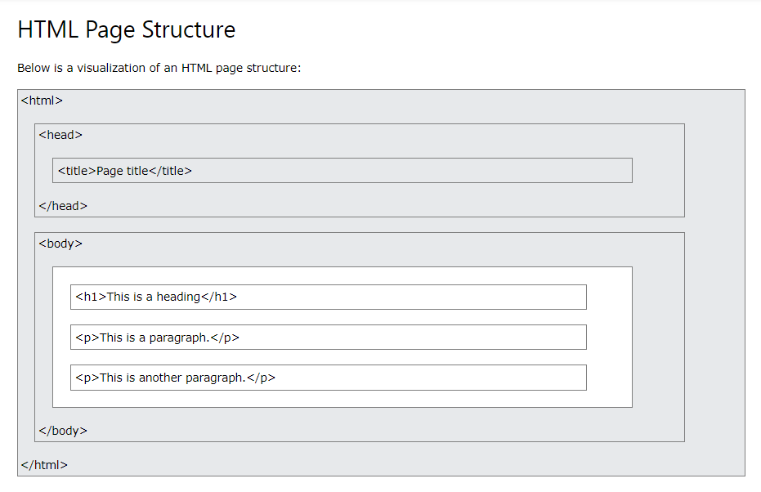

## HTML History

Since the early days of the World Wide Web, there have been many versions of HTML:

|  |  |
| --- | --- |
| **Year** | **Version** |
| 1989 | Tim Berners-Lee invented www |
| 1991 | Tim Berners-Lee invented HTML |
| 1993 | Dave Raggett drafted HTML+ |
| 1995 | HTML Working Group defined HTML 2.0 |
| 1997 | W3C Recommendation: HTML 3.2 |
| 1999 | W3C Recommendation: HTML 4.01 |
| 2000 | W3C Recommendation: XHTML 1.0 |
| 2008 | WHATWG HTML5 First Public Draft |
| 2012 | [WHATWG HTML5 Living Standard](http://whatwg.org/html/) |
| 2014 | [W3C Recommendation: HTML5](http://www.w3.org/TR/html5/) |
| 2016 | W3C Candidate Recommendation: HTML 5.1 |
| 2017 | [W3C Recommendation: HTML5.1 2nd Edition](http://www.w3.org/TR/html51/) |
| 2017 | [W3C Recommendation: HTML5.2](http://www.w3.org/TR/html52/) |

**HTML Layout Elements**

HTML has several semantic elements that define the different parts of a web page:

|  |  |
| --- | --- |
| HTML5 Semantic Elements | * <header> - Defines a header for a document or a section * <nav> - Defines a set of navigation links * <section> - Defines a section in a document * <article> - Defines an independent, self-contained content * <aside> - Defines content aside from the content (like a sidebar) * <footer> - Defines a footer for a document or a section * <details> - Defines additional details that the user can open and close on demand * <summary> - Defines a heading for the <details> element   You can read more about semantic elements in our [HTML Semantics](https://www.w3schools.com/html/html5_semantic_elements.asp) chapter. |

**HTML Layout Techniques**

There are four different techniques to create multicolumn layouts. Each technique has its pros and cons:

* CSS framework
* CSS float property
* CSS flexbox
* CSS grid